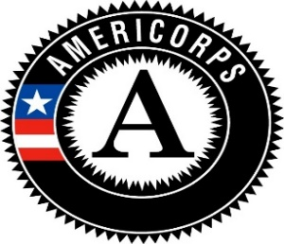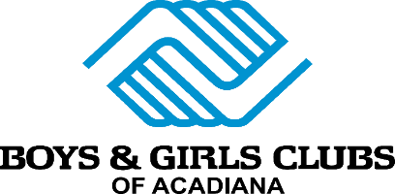

AmeriCorps openings at Boys & Girls Clubs

The Boys & Girls Clubs of Acadiana and AmeriCorps are seeking passionate, responsible, and dedicated individuals (age 17 and older) who, once they commit, will be available to serve at one of our clubs during our after-school program that will assist children as needed: Monday through Friday, beginning with PSO mandatory training in August, and in-club service from August through December. You must be able to commit to this full period of time. Please call or email us for an application and email it back to us ASAP. You may also find an application on our website at www.bgcacadiana.com or pick up and drop off an application by your local Boys & Girls Clubs.

NOTE: We ask that only applicants WILLING AND ABLE TO COMMIT to working the entire TERM OF SERVICE, at the REQUIRED TIMES SHOWN BELOW, apply. We have children that will be depending on you each day when they arrive at the clubs, and we need to assure that we will have committed AmeriCorps Members in place for them, who are willing and able to stick with the program the length of the fall term.

AmeriCorps members will complete a service term as an enrichment instructor at one of our Boys & Girls Clubs in: Abbeville, New Iberia, Lafayette, Lake Charles, Natchitoches or Opelousas. AmeriCorps members help make learning fun for Club members by planning, implementing, and evaluating activities provided within a specific program area, such as Education, Character & Leadership, Sports & Recreation, The Arts and Health & Wellness. This is a high-energy, fast-paced, noisy environment, so if these things bother you, this may not be for you!

Minimum Time AmeriCorps Members – Complete 300 hours of service total during term
Service Time – August 9, 2022- December 16, 2022*** includes MANDATORY PSO training before you begin your service with the children.

- Available Monday - Friday (2:30pm-7pm)**
- Living Allowance (term used for PAY): $2,600* per term of service (divided into pay periods every other Friday)
- Educational Award: $1,374* (paid to educational or financial institution once successfully completing term)
- Additional SLCC scholarship opportunity available to SLCC students, subject to restrictions
- Must be at least 17 years old
- U.S. citizen or lawful permanent resident
- Attend mandatory pre-service orientation PSO & BGCA training
- Living Allowance stipend paid every other Friday
- PLEASE NOTE: Living Allowance and pay are one and the same; this is basically volunteer service but with some compensation to help with living expenses while doing service with AmeriCorps.
*Amount subject to change with each grant year
** SCHEDULE IS DEPENDENT ON SCHOOL CALENDAR SO SUBJECT TO CHANGE. SCHEDULE MAY VARY BY CLUB AND WILL BE DISCUSSED UPON APPLICATION.

If you are interested, it is imperative that you get your application back to us AS SOON AS POSSIBLE as we will begin the interview process soon for our FALL 2022 term.

To apply, please contact:
AmeriCorps Grant Manager: Amy Hauser
ahauser@bgcacadiana.com
337-268-9555
Boys & Girls Clubs of Acadiana Main Office
1405 W. Pinhook, Suite 200 ~ Lafayette, LA 70503

